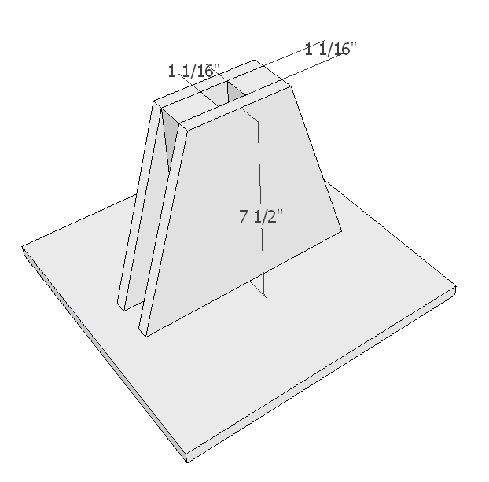
This jig can be anything really. The two musts are to have the opening a 1/16” larger than the prepared blanks which the cars will be cut from. The second is to put a hole in the bottom so sawdust can fall away and not become compacted in the bottom, if it is compacted in the bottom your holes will become inconsistent. An additional feature can be to build the jig 1 ½” shorter than the blanks. This will allow setup to be quick since you can set the maximum depth of the bit to the top of the jig so every hole will drill 1 ½” deep.

