NAME: _______________________
Name: ________________________
INSTRUCTIONS:

- Students will work in teams of two with one engine per team.
- Each team will be assigned a specific engine and will be responsible for that engine.
- Notify your teacher of any lost or broken parts.
- If you are not sure about a step or have a question, ask your teacher for help!
- Tools that are not in use are to be replaced immediately to their proper location.
- Each student must complete his or her own lab package and submit for marking.
- Each step must be completed and checked off BEFORE going on to the next step.
- Upon completion of a lab package unit, hand in for marking. When marked labs are returned, they should be placed into your binder for study purposes.
- All drawings should be done as neatly as possible. These drawings will often be referred to for engine re-assembly.
- Check answers with the engine repair manual or with your lab partner.
- DO NOT adjust or remove any part of any engine unless directed to do so.
- Obtain teacher’s permission BEFORE running an engine.
- Drawing guidelines:
  - _____________________________________________________________________
  - _____________________________________________________________________
  - _____________________________________________________________________
  - _____________________________________________________________________
  - _____________________________________________________________________
- To participate in the 4 cycle engine lab, you must understand and agree to the above conditions.
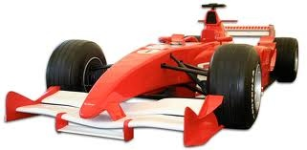
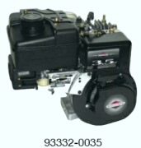

LAB PART 1
EXTERIOR

- Make (manufactured by) ______________________________________________________
- Model Number (stamped somewhere on engine) __________________________________
- Serial Number (stamped somewhere on engine) ___________________________________
- The manufacturer usually supplies a _____________________ manual with every engine to look up specifications and procedures.
- Is the horsepower (H.P.) marked on the engine? _____
- What is the horsepower of this engine? __________________________________________
- What type of equipment would an engine of this horsepower be able to operate?
  - _____________________________________________________________________
  - _____________________________________________________________________
Look at the engine parts diagram in Owner’s manual
- Where is the fuel tank located in relation to the carburetor? _________________________
- What kind of fuel does this engine burn?(look on the fuel cap) _______________________
- What is the purpose of the spark plug? ___________________________________________
- What 3 components are required in order to obtain combustion inside the combustion chamber?
  - _____________________________________________________________________
  - _____________________________________________________________________
  - _____________________________________________________________________
- Define the term “air/fuel ratio”(text glossary in book) ____________________________
____________________________________________________________________________________________________________________________________________________________________________________________________________________________________________________________________________________________________________

***FOR ENGINE PARTS LOCATOR, GO TO OWNER’S MANUAL ON THE BACK OF SHOP MANUAL

- What is the function of the air filter/cleaner? (text glossary)__________________________
______________________________________________________________________________________________________________________________________________________________________________________________________________________________________________________
- When you look under the filter container, can you see any of the filtering material? ______
- Explain how you would service this particular air filter(Cartridge Type, under general section in repair manual or Owner’s manual) ______________________________________________________________________________________________________________________________________________________
- Press two tabs on air filter housing and remove housing with air filter. ( )

Diagram #1: Make a sketch of the air cleaner body. Label where the air enters the air filter body and where it enters the carburetor.

Remove the two nuts holding the fuel tank to the cylinder head. Remove the clamp on fuel line and gently remove the fuel tank with the fuel line.

- Locate the Oil drain plug on your engine. What tool is used to open the drain plug? ________________________________________________________________________
- Open the fill plug and check if there is any oil in the engine. ( )
- If there is any oil in the engine, call your teacher
- Replace the fill plug. ( )
- Clean up and spillage that may have occurred ( )

- Locate the choke and operate it.

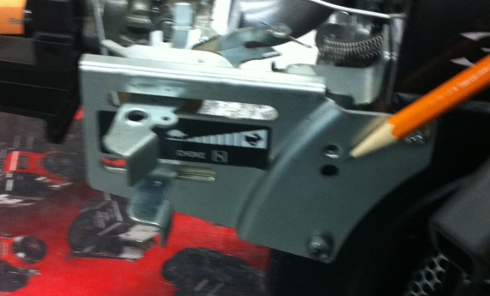 ( )
- The choke control regulates the amount of air passing through the carburetor. Turning the choke on richens the mixture for _________________ starting.
- Locate the THROTTLE control and operate it. ( )
- The throttle regulates the amount of air/fuel mixture, which is allowed to enter the cylinder for ____________________.
- If the throttle was to completely close, the engine would stop running. Therefore, an idle adjustable screw is normally provided to prevent the engine from stopping. This is called the IDLE ADJUSTING SCREW. Your engine does not have and idle adjusting screw.
- The throttle may also be connected to a GOVERNOR VANE behind the flywheel cover.

INSTRUCTIONS: Define the following terms using the textbook glossary.
- Carburetor: ________________________________________________________________
_________________________________________________________________________________________________________________________________________________________________________________________________________________________________
- Throttle (Lever): _____________________________________________________________
_________________________________________________________________________________________________________________________________________________________________________________________________________________________________
- Choke: ____________________________________________________________________
_________________________________________________________________________________________________________________________________________________________________________________________________________________________________
- Governor: _________________________________________________________________
_________________________________________________________________________________________________________________________________________________________________________________________________________________________________
- Magneto : __________________________________________________________________
_________________________________________________________________________________________________________________________________________________________________________________________________________________________________
- Coil: ______________________________________________________________________
_________________________________________________________________________________________________________________________________________________________________________________________________________________________________
- Armature: __________________________________________________________________
_________________________________________________________________________________________________________________________________________________________________________________________________________________________________
- Horsepower: ________________________________________________________________
_________________________________________________________________________________________________________________________________________________________________________________________________________________________________
LAB PART 2
EXTERNAL DISASSEMBLY
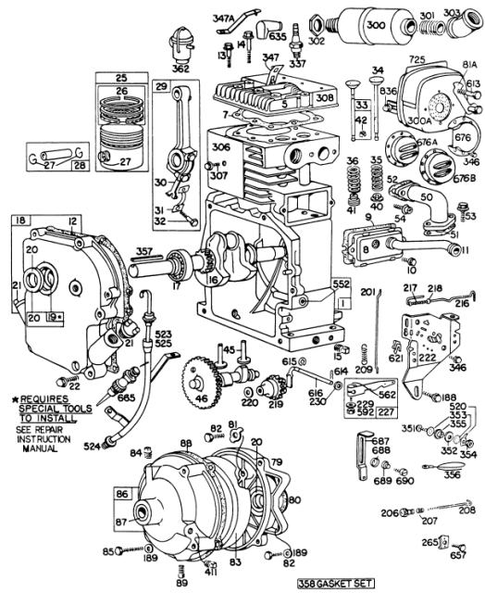

DIRECTIONS: Place all removed parts in the parts tray.

1. What 2 substances are used to keep 4 stroke engines from overheating?
  - _____________________________________________________________________
  - _____________________________________________________________________
- Remove 3 screws holding the throttle plate. Be careful not to bend the choke linkage or stretch the governor spring.
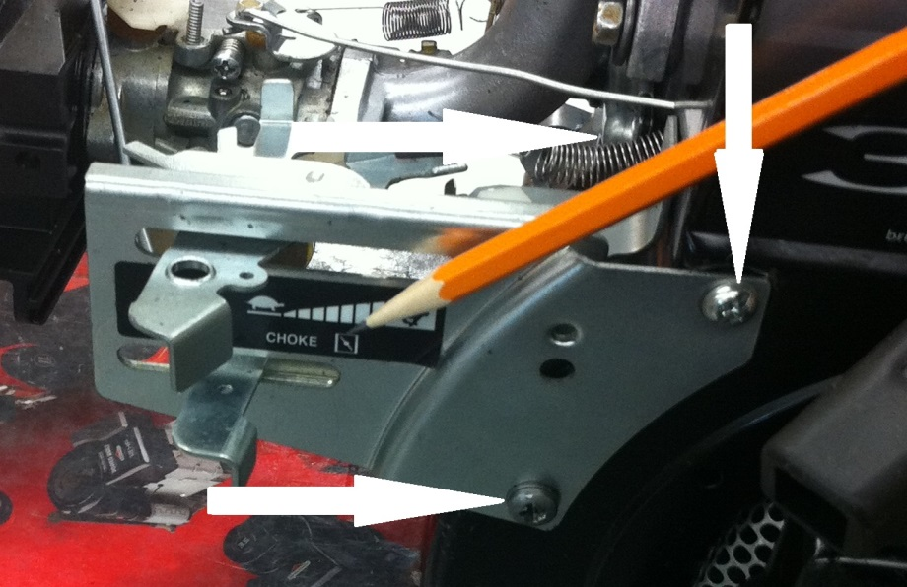
- Remove the 3 bolts holding the flywheel cover in place. ( )
- What substance is used to cool this engine? _______________________________________
- What mechanical device is used to circulate the cooling substance? ____________________
- Where is the hottest part of the engine? __________________________________________
- What is the function of the metal fins surrounding the engine cylinder and cylinder head? ___________________________________________________________________________
- What would happen if these fins become plugged with oil or dirt? _____________________
___________________________________________________________________________
- What is the function of the exhaust muffler? ______________________________________

- DIAGRAM #2: Draw a front view of the muffler on your engine.

- Locate the governor connection to the throttle. ( )
- The governor controls and regulates engine ____________________.
- One type of governor is operated by the action of spring loaded weights (centrifugal). Another type is operated by air blown from vanes on the flywheel (Air Vane).
NOTE: Be careful not to bend the governor vane.
- Which type of governor does your engine have? ________________________________
- The internal parts of the engine must be rotated to begin the combustion process. What device is used on your engine to rotate these internal parts? ______________________
_______________________________________________________________________.

Remove the governor plate, spring, and linkage from the coil and then remove the coil. ( )
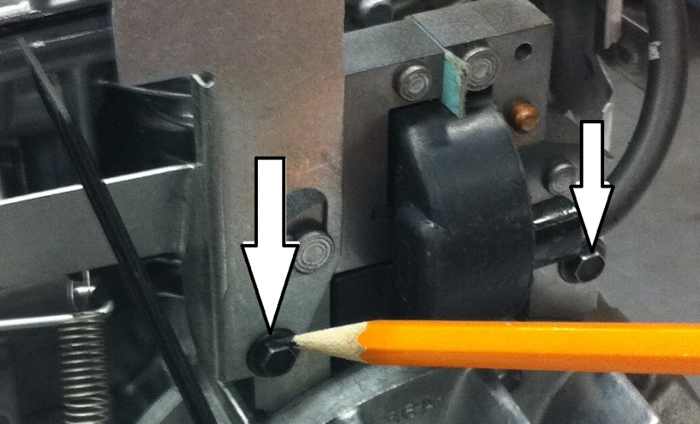

- The carburetor is the heart of the engine. It must regulate the amount of ____________________ and ____________________ that is allowed to enter the engine for combustion. Label the following carburetor parts on the diagram below. Check off each item after it has been labeled. (look in Shop manual)
( ) Idle speed screw ( ) throttle lever ( ) adjustable main jet ( ) idle mixture screw
( ) choke lever ( ) float bowl
( ) choke plate

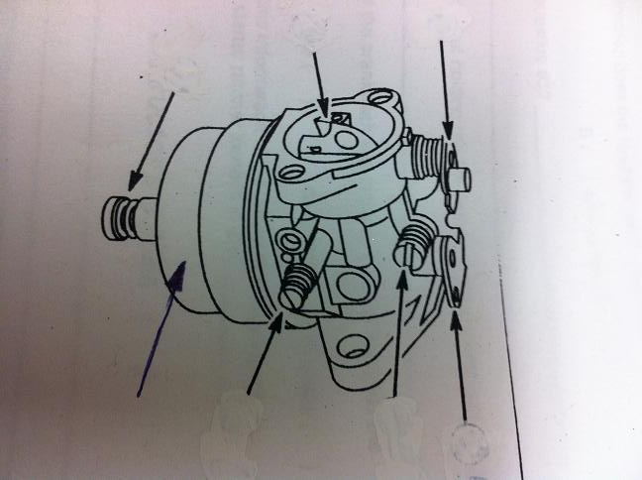

- Remove the two carburetor screws from Engine. ( )
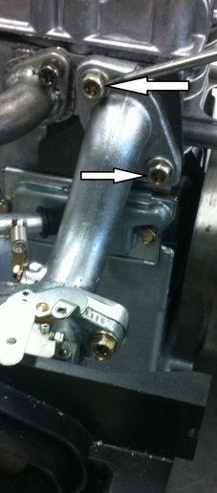
NOTE – Your engine will have a gasket between the carburetor and the engine block – carefully remove the gasket and hang it on gasket tray.
- Remove the muffler by turning two screws counter clockwise. ( )

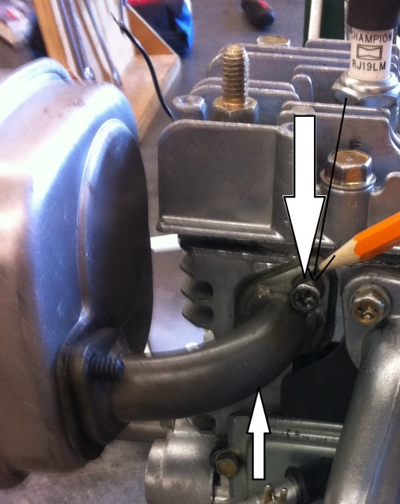

- The main purpose of the flywheel is to provide ____________________ for the engine to keep it running between power strokes.
- What other purpose does a flywheel serve?
  - __________________________________________________________________
  - __________________________________________________________________
  - __________________________________________________________________
- When the engine is running, in which direction does the flywheel turn? (Check A or B)
A. Clockwise ( ) B. Counter-clockwise ( )
- How did you determine your answer to question #22? ____________________________
_______________________________________________________________________
- If possible, study the threads on the end of the crankshaft and indicate in which direction the flywheel nut must be turned to remove it.
A. Clockwise ( ) B. Counter-clockwise ( ) C. Can’t see the threads ( )
- If the threads are not visible, refer to the repair manual for this information. This information is found on page # _____. The flywheel nut loosens in a(n) ____________________ direction.
- Remove the flywheel nut. Place all the parts in the parts tray. ( )
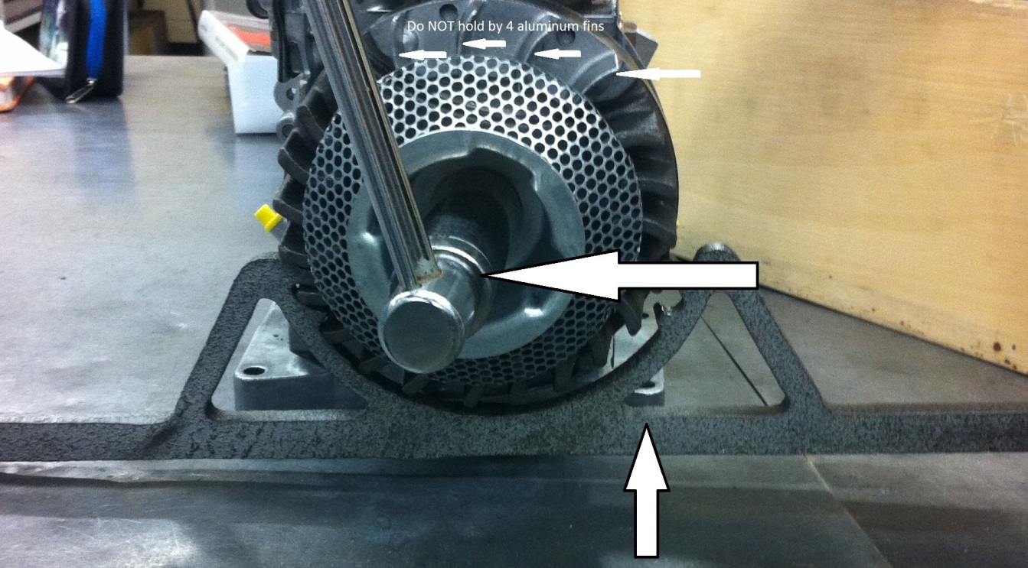
Note: In order to remove the flywheel, a soft face hammer (to strike the crankshaft) or a flywheel puller may be required. If you have any uncertainty, ask the teacher.

- Remove the flywheel. ( )

- The flywheel must lock onto the crankshaft and rotate with it. What device is used to lock the flywheel onto the crankshaft? ______________________________________.

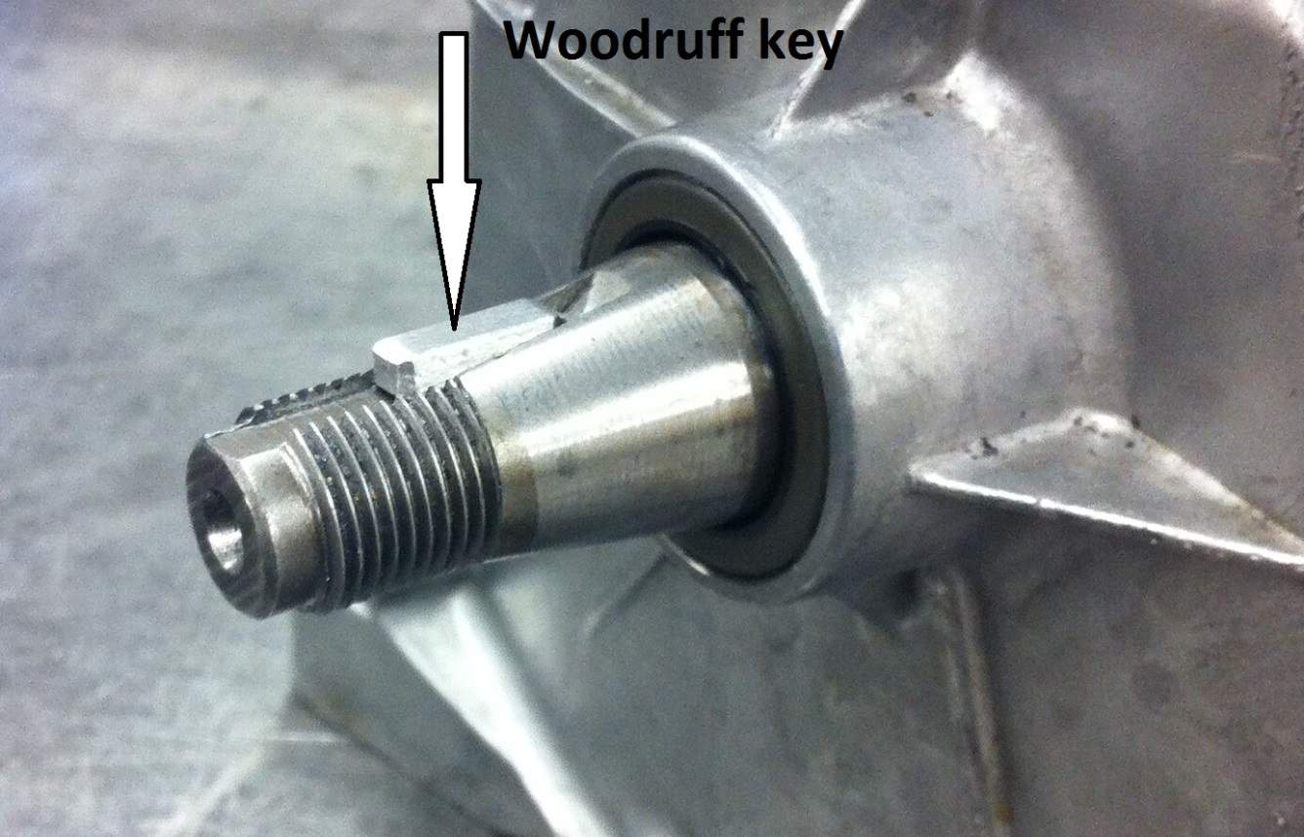

- Remove the flywheel and place it in the parts tray. ( )
- Move a screwdriver around the inside back of the flywheel. Notice that it sticks to a permanent ___________ built into the flywheel. This is a part of the magneto ignition system.
- What is the function of the magnet on the flywheel? _____________________________
________________________________________________________________________

Instructor’s initials ________________

- Diagram #5 - Label the following diagram. Hint: use the repair manual for reference. Check off each item after it has been labeled.
( ) flywheel ( ) spark plug ( ) flywheel cover
( ) armature ( ) high tension wire ( ) flywheel nut
( ) coil

- As the flywheel magnet passes across a metal plate assembly ARMATURE, it induces a current flow (creates electricity).
- The high voltage current from the magneto and Armature travels along a high tension ___________________ to the spark plug.

- Remove the spark plug using a spark plug socket. ( )
- Inspect the spark plug. Clean if necessary.
Spark plug OK Spark plug cleaned Spark plug needs replacing

- The spark plug gap should be ____________________ inches. This information is found in the repair manual.
- Adjust the spark plug gap using the wire type spark plug feeler gauge. ( )
- Have your teacher inspect your spark plug and spark plug gap. ( )

Diagram #7
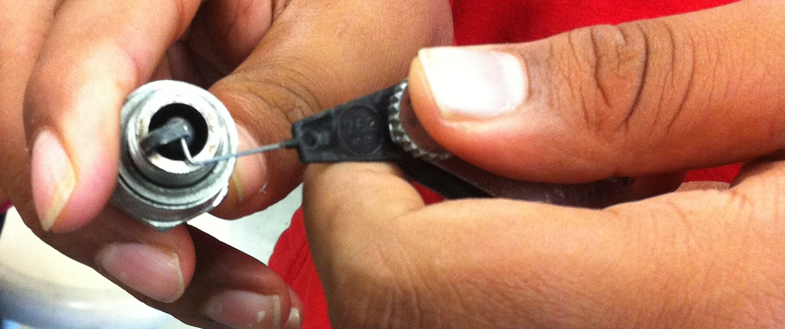

Instructor’s initials ________________

INSTRUCTIONS: Define the following terms using the class notes or textbook glossary.
- Camshaft: __________________________________________________________________
_________________________________________________________________________________________________________________________________________________________________________________________________________________________________
- Cam Lobe: __________________________________________________________________
_________________________________________________________________________________________________________________________________________________________________________________________________________________________________
- Crankshaft: _________________________________________________________________
_________________________________________________________________________________________________________________________________________________________________________________________________________________________________
- Exhaust Valve:_______________________________________________________________
_________________________________________________________________________________________________________________________________________________________________________________________________________________________________
- Intake Valve: _______________________________________________________________
_________________________________________________________________________________________________________________________________________________________________________________________________________________________________
- Valve Spring: _______________________________________________________________
_________________________________________________________________________________________________________________________________________________________________________________________________________________________________
- Valve Lifter: ________________________________________________________________
_________________________________________________________________________________________________________________________________________________________________________________________________________________________________
- Connecting Rod:_____________________________________________________________
_________________________________________________________________________________________________________________________________________________________________________________________________________________________________
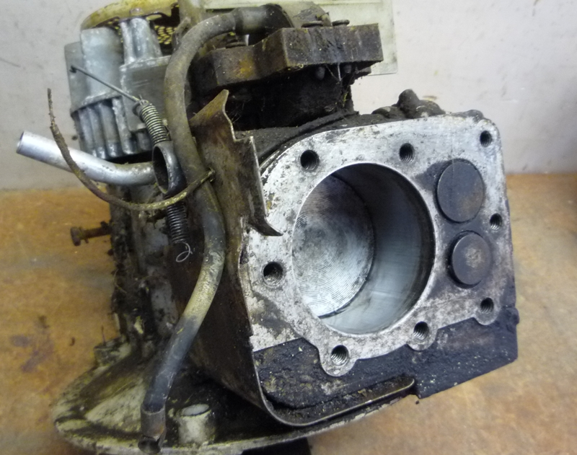
LAB PART 3
INTERNAL DISASSEMBLY

HINT: Use the owner’s manual (behind repair manual) for the following questions.
- The main lubricant used in this engine is _______________________________________
- The oil is located in the bottom of the engine called the __________________________
- What is the oil capacity of this engine? ________________________________________
- How is oil put into this engine? ______________________________________________
________________________________________________________________________
- What viscosity of oil is recommended in this engine for:
  - Summer use _______________________________________________________
  - Winter use ________________________________________________________
- List the four functions of oil in an engine:
  - __________________________________________________________________
  - __________________________________________________________________
  - __________________________________________________________________
  - __________________________________________________________________

HINT: Use the textbook to answer the following questions.

- Define “oil viscosity”
________________________________________________________________________________________________________________________________________________________________________________________________________________________
- Define “multi-grade oil” (eg 10 w 30)
________________________________________________________________________________________________________________________________________________________________________________________________________________________
NOTE: Not all of the cylinder head bolts are the same length.
- Remove the cylinder head. Take care not to damage the head gasket. ( )
- Do not peel the head gasket. ( )
- Notice that the cylinder head gasket is different than other gaskets you’ve removed. Why is the cylinder head gasket special? _______________________________________________
______________________________________________________________________________________________________________________________________________________
- DIAGRAM #8 - Using your cylinder head as a template, draw a full size diagram of your cylinder head and label the following terms.
( ) cylinder head ( ) cylinder head fins
( ) location of long bolts ( ) Spark plug hole
( ) location of short bolts

- Remove the engine crankcase cover. ( )

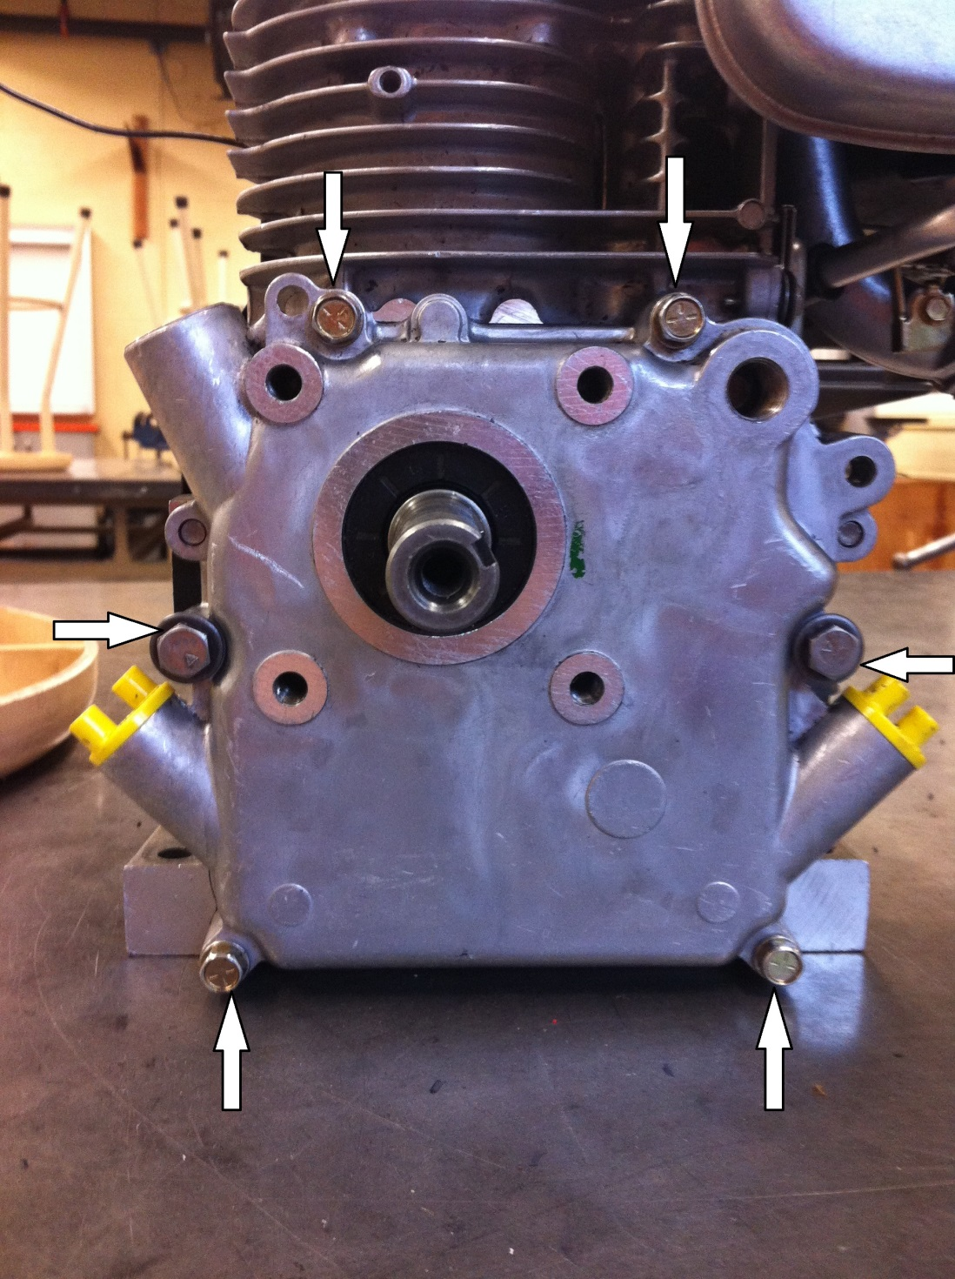

- If the crankcase cover gasket is in good condition, give it to the teacher for storage. If not, give it to the teacher for replacement. ( )
- Locate the crankcase breather cover (also called the valve cover). ( )

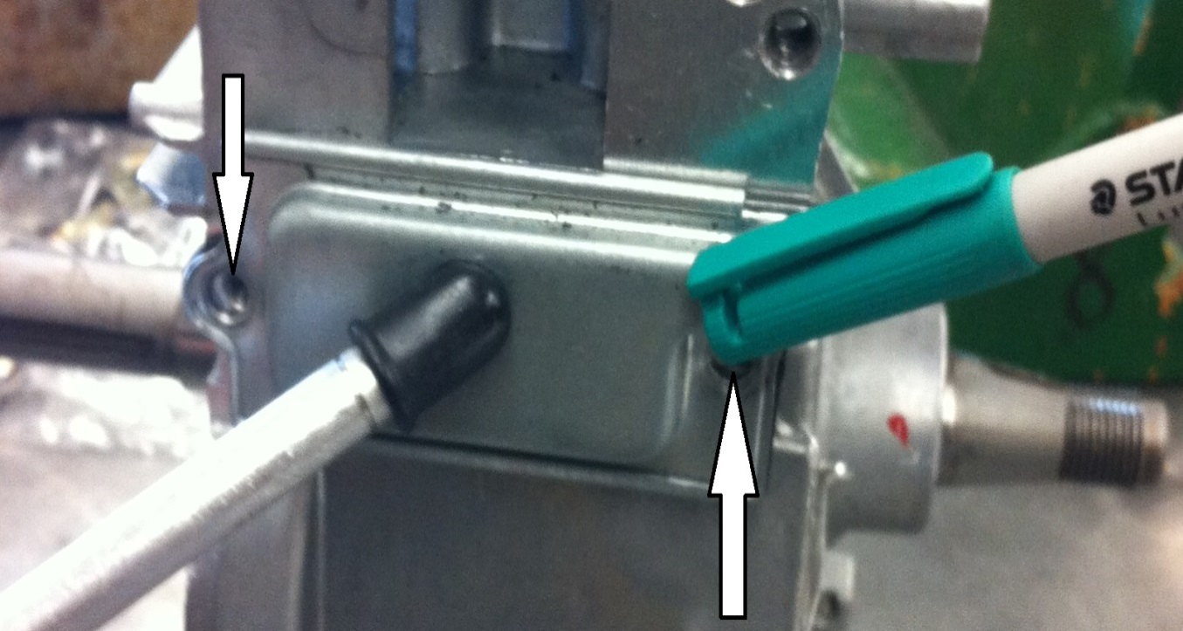

- Remove the 2 screws holding the valve cover in place. Remove the valve cover. Replace the screws. If the gasket is in good condition, give it to the teacher to place in the gasket container. If not, give it to the teacher for replacement. ( )
- Give the valve cover a shake. You should hear a slight rattle sound. The reed valve inside the cover causes this rattle. What is the purpose of the reed valve? __________
___________________________________________________________________________
- The engine must allow for the lubrication of its internal components. The oil in the reservoir must use a pumped, splashed or thrown onto the moving parts. This engine uses an oil slinger to distribute the oil. Locate the oil slinger. ( )
- What component is the oil slinger attached to? ____________________________________

- Diagram #9: Draw a diagram of the oil slinger used in this engine. Include a side view of the foot which splashes the oil as it is rotated inside the crankcase.

- All engines require some sort of valves to control the inlet of the air-fuel mixture into the engine and the exhaust of burnt gases out of the engine.
- Some engines use poppet type valves while other engines use the piston and ports in the cylinder wall.
- Locate the valves in this engine. Are they poppet, or piston and port type? _____________
- Are the valve heads in this engine the same diameter? ________ Which valve head is the larger diameter (intake or exhaust)? ___________________ Why (hint: look up the term “volumetric Efficiency”) _______________________________________________________

- Locate the following valve train components on your engine.
( ) valve head ( ) valve spring
( ) Valve lifter ( ) Valve seat
( ) valve guide ( ) valve margin
( ) valve stem ( ) valve face
( ) camshaft ( ) cam lobe
( ) port
- Diagram #10: Label the above train valve components on the diagram below. (use the small engine book, page-72 & 74)

- Does the valve lifter in your engine look the same as the one in Diagram #10? __________
- In order for engine to operate properly, it must be timed. There are two types of timing required. Explain each (hint: use the textbook as a reference).
  - Valve timing: __________________________________________________________
__________________________________________________________________________________________________________________________________________
  - Ignition timing: ________________________________________________________
__________________________________________________________________________________________________________________________________________
Remove crankshaft bearing
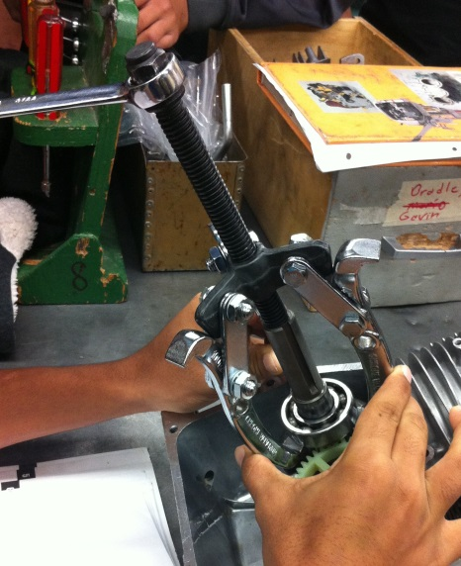
- Locate the timing gear on the end of the camshaft. How many teeth does it have? ________
- Locate the timing gear on the end of the crankshaft. How many teeth does is have? _______
- What is the ratio of the camshaft gear to the crankshaft gear? ________________________
- Why is this ratio important? ____________________________________________________
______________________________________________________________________________________________________________________________________________________
- In order for the valve opening and closing to be properly timed to the piston, the timing mark on the crankshaft gear must be perfectly lined up with the timing mark on the camshaft gear. Locate these timing marks.
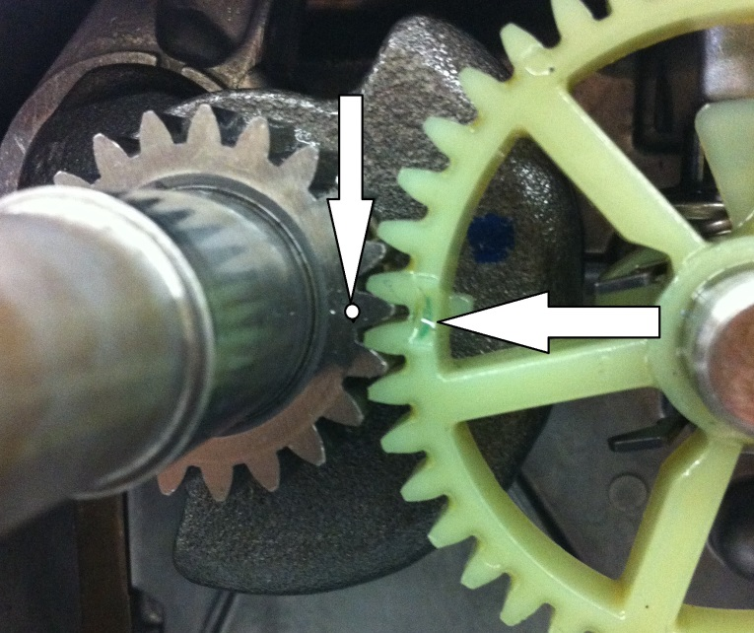

- Diagram #11: Draw the interlocking circles to represent the timing gears on the end of the crankshaft and camshaft. L:abel the following:
( ) crankshaft gear ( ) camshaft gear
( ) timing marks

Instructor’s initials ________________

- Rotate the engine crankshaft to line up the timing marks. With the engine upside down, pull the camshaft straight out. ( )
- Remove the valve lifters. ( )
- Locate the valve spring. Below the valve spring is a keeper which locks the valve spring to the valve stem. The keeper is in the shape of a washer. Note that the washer has a slotted hole to allow it to lock onto the end of the valve stem. The washer must be removed in order to remove the rest of the valve train.
- Diagram #12: Slotted Washer

- The tool used to compress the valve spring so the keeper can be removed is called a _________________________________ .
- Remove both valve springs and keepers (re-assemble all valve parts so none get lost). Place in the parts container. ( )
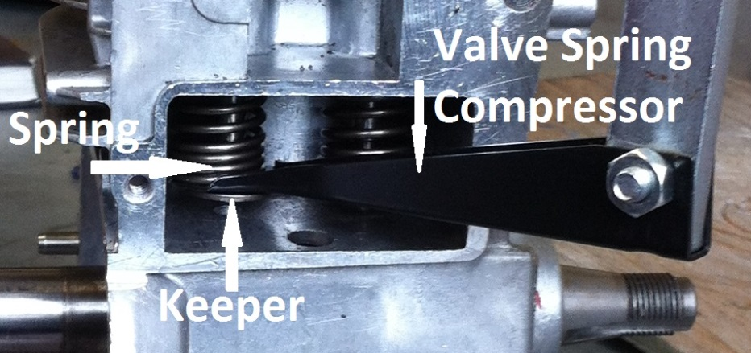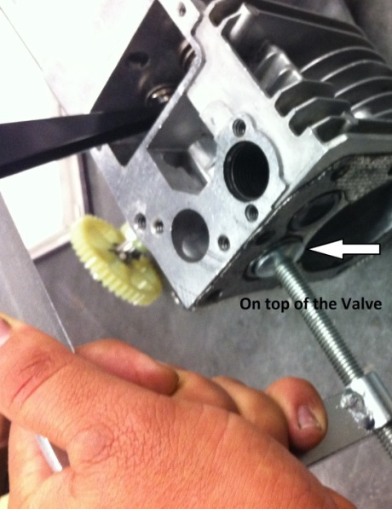
- When the valves are removed, clean all parts and inspect them for the following:
Cracked or pitted face, head or stem ( )

Bent or damaged components ( )

Note: if any problems exist, notify the teacher.
- In order to remove the piston assembly from the engine, the bottom half of the connecting rod must be removed from the connecting rod. What is the bottom half of the connecting rod called? ______________________________ .
- Look at the direction the bolt heads are facing on the connecting rod cap (towards, or away from the valve cover)? _________________________.

- Loosen the 2 con-rod bolts with a six point socket. ( )
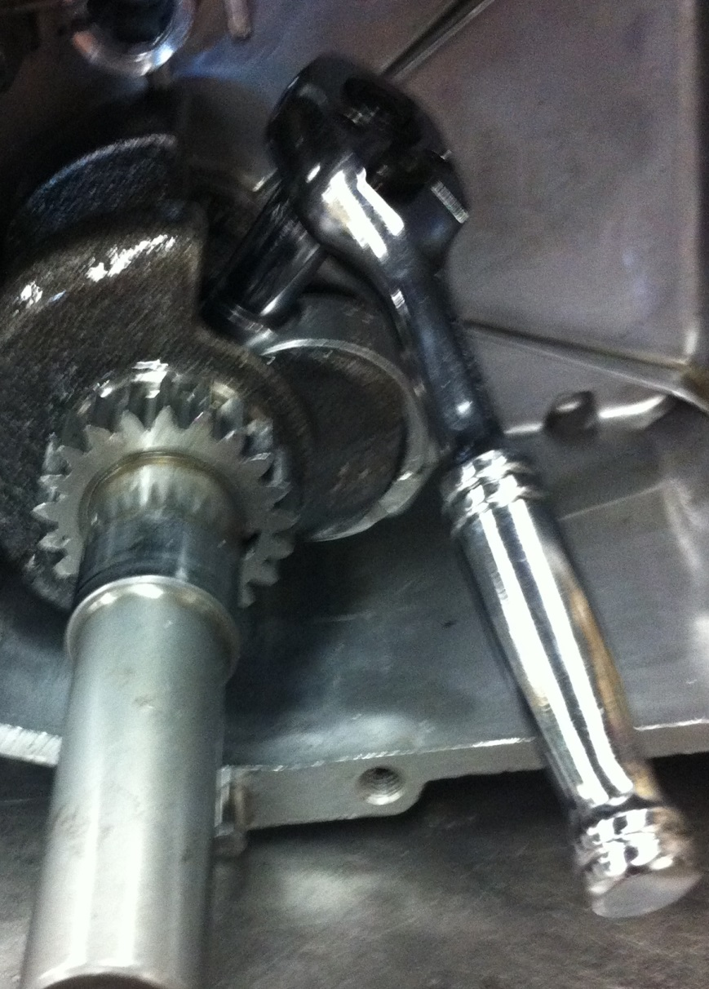
- Use an 8mm wrench in order to finish removing the bolts. ( )
- Remove the connecting rod cap. ( )
Look at the notch on top of the piston and make a note of the direction it is facing in. Which way is it facing (Away, or towards flywheel)? ______________
- Remove the piston and con-rod assembly by pushing it out the top of the cylinder. ( )
- Remove the crankshaft by pulling it out of the crankcase. ( )
- How many piston rings are on this piston? __________________________________
- Diagram #13: Using the repair manual, find out the names and function of each of the piston rings. Also, draw a cross-section view of each piston ring to show its unique shape.
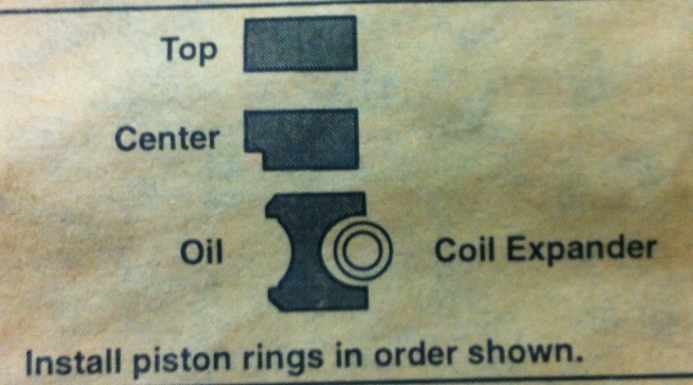
(Use Shop manual, section 9, page 5, Fig. 10)
  - Top Ring:
  - Name: _______________________________________
Function: ________________________________________________________
_______________________________________________________
Diagram:

  - Middle Ring:
  - Name: _______________________________________
Function: ___________________________________________________________
____________________________________________________________
Diagram:

  - Bottom Ring:
  - Name: _______________________________________
Function: ___________________________________________________________
____________________________________________________________
Diagram:

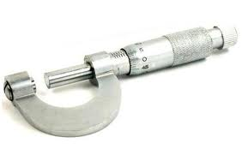
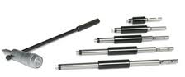
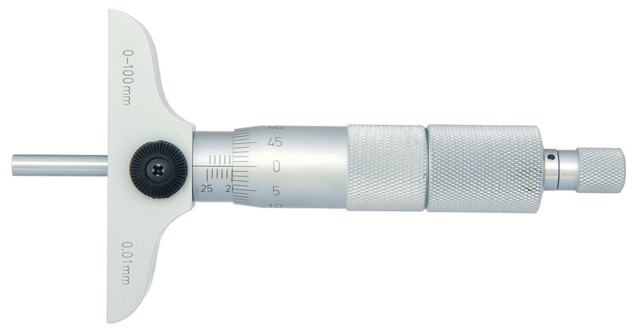
LAB PART 4a
INTERNAL MEASUREMENTS

- The connecting rod and crankshaft journal must fit within a very close tolerance. This is because:
  - A bearing that fits too tight will have no room for lubrication and the bearing will _____________________________________________________________________
  - A bearing that fits too loose, the lubricant will run out and the bearing will shake and pound to pieces.
- With time, a bearing will also wear into or seat into the shaft or journal it rotates around. It’s important that all bearings and journals be re-assembled the same way they were removed. To permit this accurate re-assembly, the con-rod cap has assembly marks. Locate the assembly marks on your engine con-rod cap. ( )
- Using the repair manual, find out how these marks should be positioned. The diagram showing these marks was found on page __________ Figure # __________.
- How should these marks be positioned in relation to each other? ______________________
___________________________________________________________________________
- Diagram #14: Draw a diagram of the assembly mark used on your engine. Label the following on your diagram:
( ) con-rod ( ) con-rod cap
( ) assembly marks
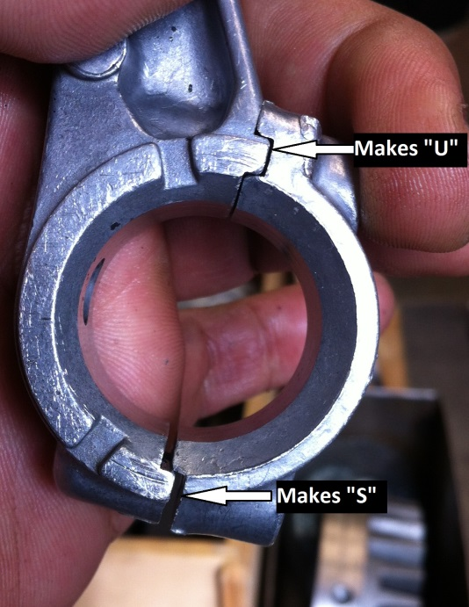
Instructor’s initials ________________

Reference the repair manual Section 10, page 4, fig. 7
- Do a visual inspection of your engine crankshaft and check for the following defects:
  - Scored, pitted or damaged bearing surfaces
  - Bent, cracked or broken
  - Damaged keyway
  - Damaged flywheel taper
  - Damaged or stripped threads
Crankshaft OK Crankshaft damaged

Note: If any of the above defects are found, notify the teacher.
- Record the following crankshaft reject sizes from shop manual (use specifications for a 94000 Basic Model Series Engine)
  - P.T.O (Power Take Off) journal __________________
  - Mag (Magneto) journal (flywheel end) ____________
  - Crankpin (con-rod journal) _____________________
- Use a micrometer and measure following spots on crankshaft.

- Check your crankshaft measurements (question #3) with the reject sizes in question 2. Your crankshaft measurements should not be smaller than the reject sizes. (Check one of the following):
  - Measurements are within specifications

  - Measurements smaller than the reject sizes

Have teacher initial before going on… Teacher’s initials

Reference the repair manual Section 10 (Use 94000 engine model)
- Do a visual inspection of your engine camshaft and check for the following defects:
  - Scored, pitted or damaged bearing surfaces
  - Bent, cracked or broken
  - Damaged gear teeth
Camshaft OK Camshaft damaged

Note: If any of the above defects are found, notify the teacher.
- Using the manual and write specifications for your Engine, locate the following reject sizes:
  - Camshaft journal gear end _____________________
  - Camshaft journal other end ____________________
  - Intake cam lobe height ________________________
  - Exhaust cam lobe height _____________________

Use micrometer and record the following measurements. 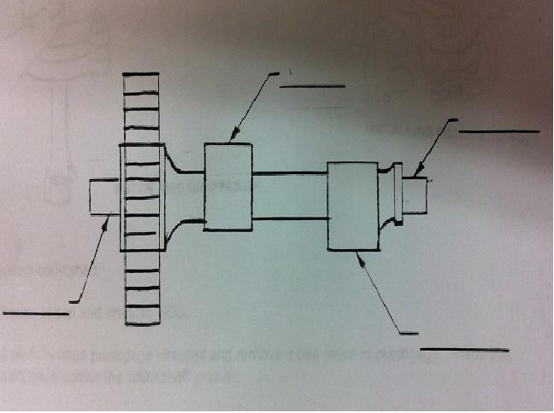

Have teacher initial before going on… Teacher’s initials

Instructions: Check off each step when complete.
- Why must we have clearance between the con-rod bearing and the crankshaft journal?
__________________________________________________________________________________________________________________________________________________________________________________________________________________________________________
- Thoroughly clean the piston, con-rod assembly and crankshaft. ( )
- Using fresh clean oil supplied by the teacher, lubricate the entire side surface of the piston with a generous amount of oil. CAUTION- The piston will be slippery. Extra care must be taken to not drop or damage the piston.
- Install the crankshaft. ( )
- Which direction should the notch on the top of piston head should face? ( )
- Call your instructor to install the piston.

- Lay the engine side-ways; push the piston and rotate the crankshaft to BDC. ( ) 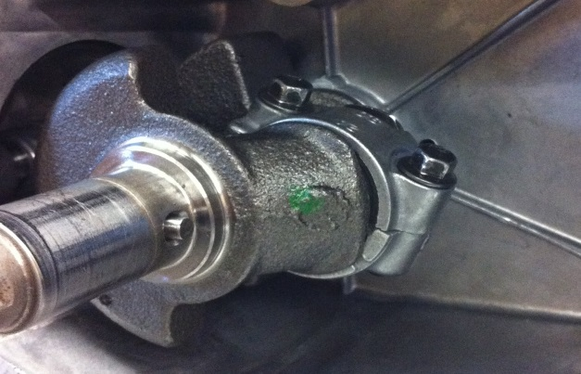
- Ask for a piece of plastigauge from your teacher. Place this plastigauge across the crankshaft journal (use oil on the cap).
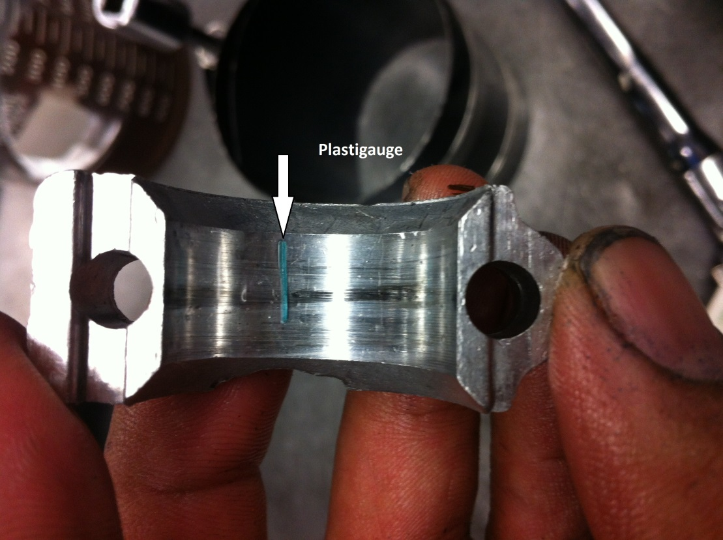
- Install the con-rod cap and bolts. ( )
- When installing the con-rod assembly and cap, how is the alignment marks positioned? _________________________________________________________________
___________________________________________________________________________
___________________________________________________________________________

- Using the repair manual, find the torque specifications for the con-rod cap screws. The torque is equal to _______________ in/lbs.
- Have the teacher check the following:
  - Alignment marks

  - Torque specifications (step 9)

Teacher’s initials

- Torque the bolts to the specifications. ( )
Note: Do not turn the crankshaft otherwise the plastigage will be ruined.
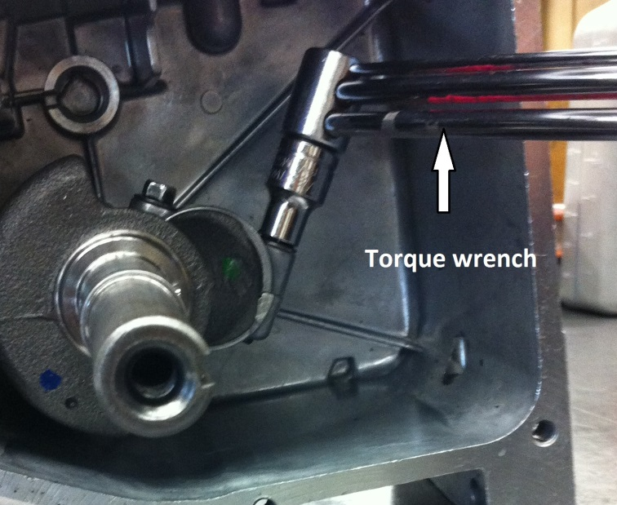
- Remove the bolts and con-rod cap. ( )
- Measure the widest part of the plastigage using the wrapper scale (see diagram below). The clearance is __________ Thousandth __________ millimeters.
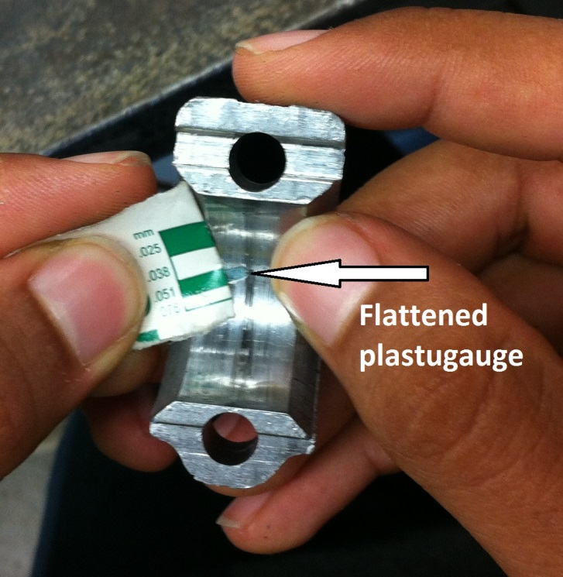

- This con-rod clearance for this engine should be MIN. 0.002 inches and MAX. 0.004 inches. Compare with your measurements in step 13. (Check one of the following):
  - Clearance within specifications

  - Clearance not within specifications

Have teacher initial before going on… Teacher’s initials

15. Using your fingernail, and carefully scrape off all the remaining plastigauge from the cap and crankshaft. ( )

16 Re-install the connecting rod cap, with oil slinger and torque both bolts to 75 inch/lbs.
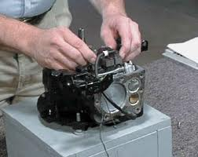
LAB PART 4b
ENGINE RE-ASSEMBLY

Instructions: Check off each step as it is completed.
- Set the valve springs on end and side by side. Does one spring appear to be made of stronger and thicker wire than the other? Yes No

- If one spring is stronger, which valve does it belong on?______________________________
Why? ______________________________________________________________________
___________________________________________________________________________
- With the tip of the finger, LIGHTLY grease the intake and exhaust valve stems. ( )
- Using a valve spring compressor install the exhaust valve, exhaust valve spring,
and retainer. ( )
- Install the intake valve, intake valve spring and retainer. ( )

Have teacher initial before going on… Teacher’s initials

- Calculate the piston Displacement for your engine.
Using the Glossary in the textbook
- Define the term Bore: ______________________________________________________
___________________________________________________________________________

Measure the bore of your engine using an inside micrometer. (This micrometer is 2”-3”
Which means you’re reading will be 2.- - -“)

The bore is (d) ________________________ inches.

- Define Stroke_____________________________________________________________
________________________________________________________________________

Measure the stroke of your engine. The stroke is B.D.C. – T.D.C. (One of the depth micrometers is 1”-2”)

Total measurement is ______________ inches. (Your answer should be 1. - - - )
- Define Piston Displacement _____________________________________________
___________________________________________________________________________

Calculate the piston displacement of your engine (show all work)
0.7854 X $d^{2}$ X length of the stroke

Displacement = ________________________cubic inches.

If your engine has eight cylinders, what would be the piston displacement for eight cylinder engine? ____________________________ cubic inches. Show all work.

Have teacher initial before going on… Teacher’s initials

- Refer to the engine manual. In the chapter on Crankshaft and Cam gears, locate and read the section titled INSTALL CRANKSHAFT AND CAMGEAR. This paragraph is found on page __________. The accompanying illustration is figure number ___________.
- What shape is the timing mark on the crankshaft timing gear? _______________________
And on the camshaft gear? ______________________________.
- Rotate the crankshaft until its timing marks are facing each other. ( )
- Using the tip of finger, lightly oil camshaft journals, cam lobes and lifters. ( )

Place the engine up-side-down

- Install both lifters and the cam gear. Are the valve timing marks line up correctly?
Yes No

- Have the teacher check and initial the following:
Timing marks valves in correct ports

Con-Rod Bearing Cap spring on correct valves

Oil slinger valve retainers

Tappets (lifters)

Teacher’s initials

Ask your instructor to Install crankshaft Bearing
- With the tip of finger, lightly oil crankshaft journal. ( )
- Install the crankcase cover gasket. ( )
- Replace the crankcase cover. Torque the bolts to 25 In/lbs. ( )
- Refer to the repair manual. In the chapter CRANKSHAFT AND CAMGEARS, locate and read the section titled CRANKCASE COVER and CRANKSHAFT END PLAY. The end play should be between __________ inches and __________ inches.
Is your end play within the specifications? Yes No

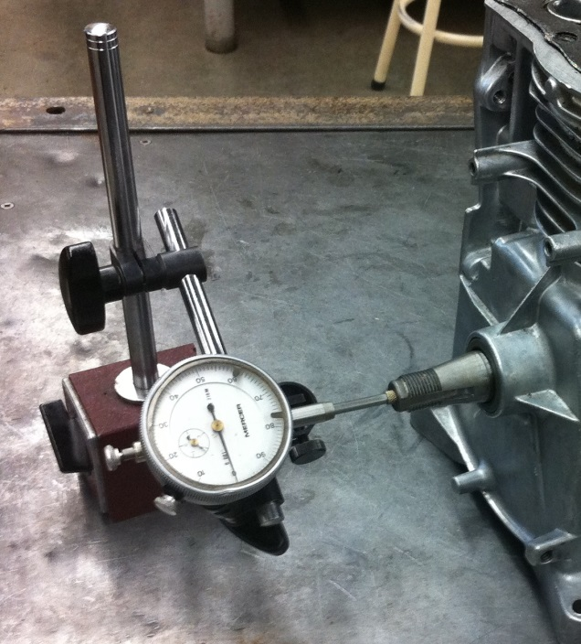
Measuring Valve Clearance
- The valve clearance for this engine should be:
  - Intake valve __________ to ___________ inches.
  - Exhaust valve __________ to ___________ inches.

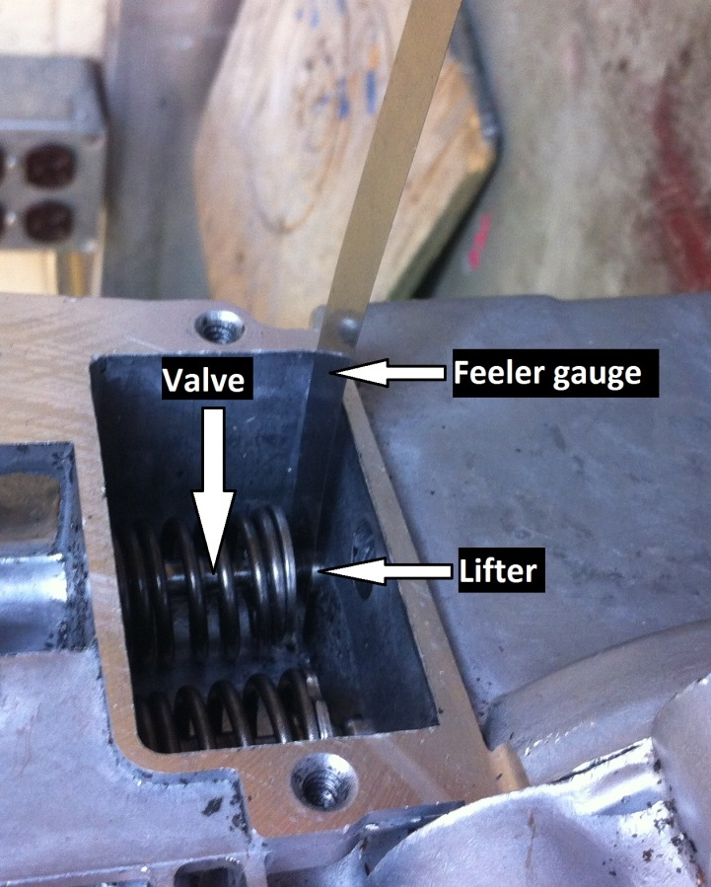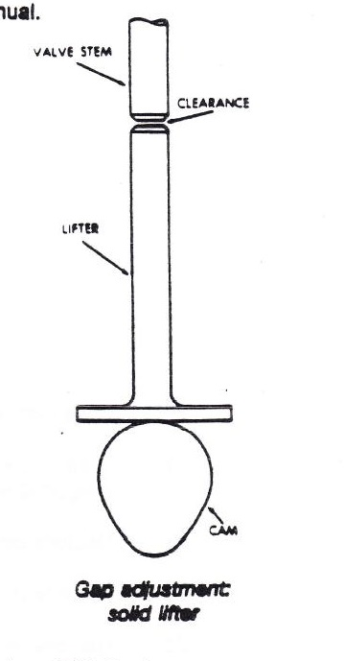

- Valve clearance should be checked and adjusted with the piston at T.D.C. of the ___________ stroke. (Stroke in which both valves are closed and piston moves up).
- Measure and record the valve clearance for your engine:
  - Intake Valve: ____________________
  - Exhaust Valve ____________________
- Is your end play within the specifications? Yes No

Have teacher initial before going on… Teacher’s initials

- Install crankcase breather cover (valve cover) and gasket. DO NOT OVERTIGHTEN the two screws. ( )
- Replace the muffler and gasket. ( )
- Attach the carburetor to the engine block using gasket. If possible, torque the two screws to 40 inch-pounds. ( )
- According to the repair manual the required torque for the flywheel nut is ____________________ in/lbs.
- Locate and slide woodruff key halfway into the keyway. ( )
- Slide the flywheel carefully over the key. ENSURE key and keyway line up. Install the washer and nut onto flywheel. Torque nut to 30 ft/lbs.
- Complete the following: (Make sure the governor and linkage is installed)
- Attach the linkage from carburetor to Governor vane. ( )

Install two screws on to the ignition coil with governor vane attached ( )

Measure Flywheel to Armature Air Gap
- The Armature Gap should be:
  - Min. ____________________
  - Max ____________________
- Move the magnet on flywheel to 6 O’ clock.
- Insert the feeler gauge under the coil, Press the coil down with fingers, and tighten the two screws.
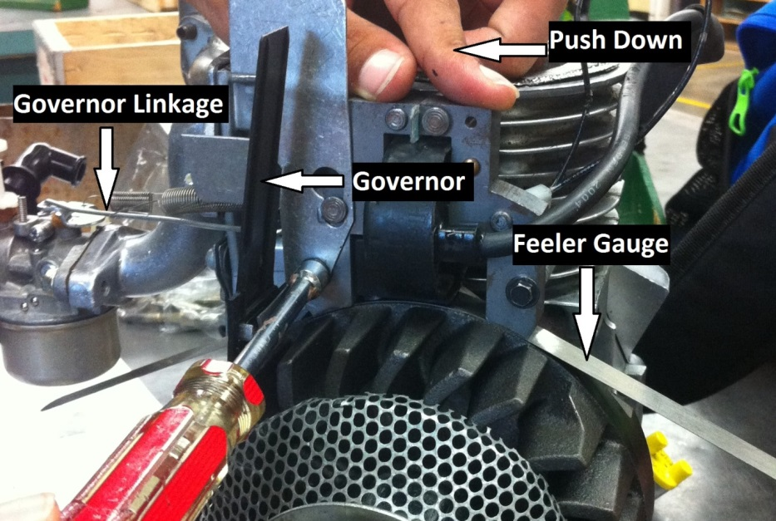 Teacher’s Signature.

- Refer to the chapter on COMPRESSION in the service repair manual. Locate the figure which displays the various cylinder heads for different model engines. This is figure number _____ on page __________.
- Locate the illustration which corresponds to the head design for this engine. Notice that certain holes are shown to use LONG screws. Note also that the TIGHTENING SEQUENCE for all the screws is shown in the diagram.

- Label the following diagram of the cylinder head, Diagram 8 on page 17 of your lab for reference.
( ) long bolt holes ( ) tightening sequence

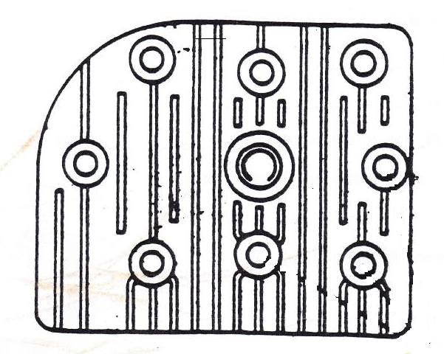

*** GET THE HEADGASKET LOOKED AT BY YOUR TEACHER

- Place gasket and head onto engine block. ( )
- Turn the screws in all the way but do NOT TIGHTEN. ( )
- According to the service manual, the required torque for the HEAD BOLTS on this engine is____________________ in/lbs.

- Have the teacher check and initial the following:
Three long head bolts in the correct holes

Governor attached properly and working freely
Torque information for the cylinder head bolts

Teacher’s initials

- By following the TIGHTENING SEQUENCE, use a torque wrench to tighten the bolts to a torque of 50, 100, and then to 140 inch-pounds. DO NOT EXCEED this torque as the soft aluminum threads may strip. Remember to tighten in three stages . ( )
- Check to see that the spark plug wire leads up through the groove provided in the air collector. ( )
- Replace the flywheel cover. Torque the three bolts to 30 inch/lbs. See that the cover fits properly all the way around. Governor throttle spring should be OUTSIDE of the cover.
- Install Choke linkage on choke/throttle plate and install plate on flywheel cover. ( )
- Attach the governor spring to the throttle control lever. ( )
- Install fuel tank and fuel line. Snug two nuts that hold the fuel tank. ( )
- Replace air cleaner so that it is lengthwise over carburetor. ( )

Call instructor for spark test

(Use an insulated player to hold the spark plug).

- Perform a spark plug test on the spark plug by attaching the spark plug wire and holding the metal base against a metal component of the engine. Pull on the starter rope and observe if a spark is visible.
- O.K. No spark - notify teacher

- Install the spark plug and torque to 50 in/lbs. ( )
- Attach spark plug wire. ( )
- Obtain teachers initial in preparation for engine run-up.

Teacher’s initials

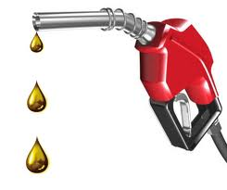
LAB PART 5
ENGINE START-UP

SAFETY
- Gasoline is very flammable and should be handled with extreme caution.
- Work in a well-ventilated area
- Know the location of fire extinguishers and how to use it.
- Ensure oil drain plug is tight. ( )
- The engine oil viscosity is ____________________ ( )
- Fill engine crankcase to point of overflowing with correct oil. ( )
- Fill fuel tank ¼ full of gasoline. ( )
- Remove fuel container at least 10 feet from run-up area. ( )
- Have the teacher check before proceeding:
  - Oil level

  - Fuel level

  - All caps and plugs in place

Teacher’s initials

Choke engine slightly and attempt to start engine
Note: If engine fails to start, notify the teacher or if any strange noise exists – STOP
ENGINE IMMEDIATELY and notify the teacher.
- When the engine has started, run at normal operating speed (approx 1750 r.p.m.). Close needle valve (clockwise) until engine starts to lose speed. Then slowly open the valve (counter clockwise) until the engine runs smoothly and evenly (approx ½ turn). ( )
- Notify the teacher before stopping the engine

Teacher’s initial

NAME: _______________________

- Stop engine with “kill switch” ( )
- Drain fuel into appropriate container. ( )
- Darin oil into appropriate container. ( )
- When completed, complete the following:
  - Clean and return all equipment
  - Clean all tools and put away
  - Return engine to storage cabinet

- Notify the teacher Teacher’s initial
- Submit Lab for evaluation

Congratulations!

