Breadboard Lab #4
“How a diode works”
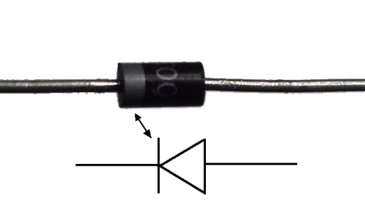

- Breadboard the following schematic diagram. Make sure your wires are flat! Make sure the CATHODE (end with the silver band) of the diode is connected to the negative. Set the Power Supply to 9 volts.

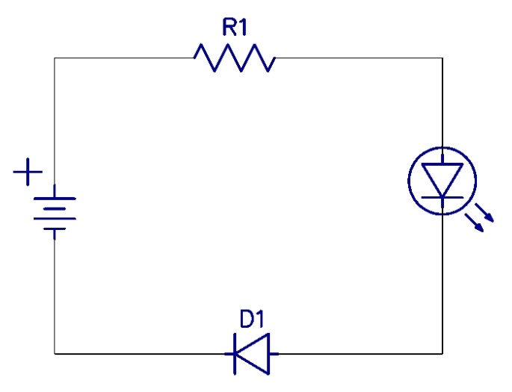

R1: 330 ohm (Orange, Orange, Brown, Gold)
D1: 1n4002 - 1n4007 Diode

- Now, switch the diode around so that the ANODE is connected to the negative. What is the difference? Use the PowerPoint presentation from class to answer to help.

- Answer the following questions. Use your notes to help.

  - A diode allows current to flow through it in only ______________ direction.

  - A diode has two ends, the _______________ and the ______________.

  - When the _______________ is connected to negative, the LED will light up.

  - If the ______________ is connected to negative, the LED will NOT light up.

