Breadboard Lab #5
“How a capacitor works”

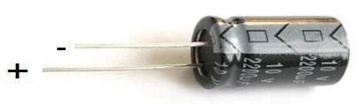

- In this lab you will use electrolytic capacitors as shown

- Breadboard the following schematic diagram. Make sure your wires are flat! Set the Power Supply to 9 volts.

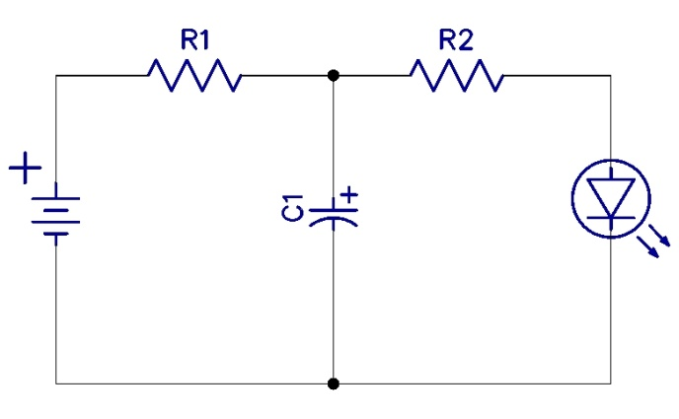
R1: 1K (Brown, Black, Red, Gold)
R2: 330 (Orange, Ornage, Brown, Gold)
C1: 10uf

- Connect the circuit to the power supply and the light should come on. Disconnect it, what happens to the LED? Now, replace the 10uf capacitor with a 1000uf capacitor, what is the difference when you disconnect the power?

- Answer the following questions. Use the PowerPoint presentation from class to answer to help.

  - A capacitor stores __________________.

  - Once you disconnect the power to the circuit, the LED will _____________________ for a while because of the stored electrical energy in the capacitor.

  - The greater the value of the capacitor, the ________________ the LED will stay on.

  - When current flows through the circuit, what is happening to the capacitor?

