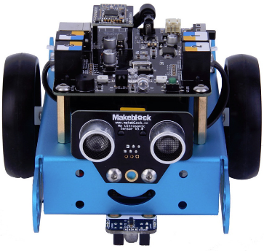Welcome to your first robotics lab!

**Goal:**

In this lab you will be learning about Mbot which is a small educational robot that can be programed to do a number of different operations.

[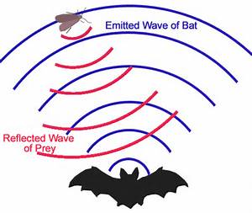](http://www.bing.com/images/search?q=ultrasonic+waves+kids&view=detailv2&&id=290A5C626CA1EF023D70F3215F7B7A6DC41CCF43&selectedIndex=0&ccid=h3deryu%2f&simid=608009976915559986&thid=OIP.M87775eaf2bbf90881964043d984b579eH0)**Parts:**

Eyes: Located at the front of MBot you will find two eyes directly above a smile. These are ultrasonic sensors. Just like how a bat can send out sounds and have them bounce back to show them where objects are so can the Mbot. This allows Mbot to avoid walls and other objects while driving.

Feet: Mbot’s feet are its wheels, motors and gearing. Each wheel is controlled separately from the other. When voltage is sent to the motor the wheel turns forward. If the opposite voltage is sent to that motor the wheel turns the other way. If only one motor is turned on, Mbot will turn. If both motors are turned on in the same direction Mbot will drive in that direction. Different levels of voltage will allow Mbot to drive at different speeds.

Brain: On top of Mbot there is a black board, try not to touch the parts on it unless you are told to by your teacher. This board allows sensors and motors to talk to the computer. It can also hold programing so Mbot can travel without a computer plugged into it. This board is designed using Open source technology called Arduino. Open source means anyone is welcome to see how the technology is build and change it to fit their own design. Arduino is a very popular type of technology called a microcontroller. Microcontrollers can be found in 3D printers, Fridges, Cars, Coffee Makers and more. Chances are you have used at least one microcontroller today without realizing.

Heart: The heart of Mbot is the power supply. Mbot can run without a power supply if it is plugged into the computer using a USB cable. When not connected Mbot will need a power pack or a power supply. Mbot’s power pack has 4 - 1.5 volt AA batteries running in series, this means the voltage of the batteries are added together. Mbot can use any voltage between 3.7 volts and 6 volts; this means we have options when using a power supply plugged into the wall.

Fingers: Under the front of Mbot you will see two clear LEDs and two black sensors. These are infrared sensors (IR sensors for short) that let Mbot see what color of material it is driving on. This can allow Mbot to follow a line and stay on course like of like an invisible hand railing.

Nerves: There are wires all over Mbot. These send signals in the form of electricity to and from the sensors, motors and brain. Don’t play with these please, Mbot is sensitive and you don’t want to get on his or her nerves.

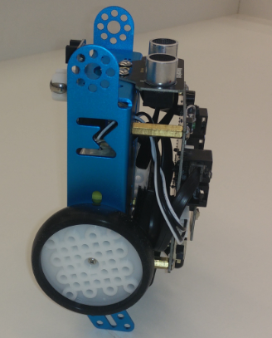**Using Mbot:**

Whenever using Mbot it should be stored on a cleared off desk away from the edge of the table. Mbot will actually stand on its back using the two blue tabs behind the wheels. When programing, it is best to have Mbot resting on its back so it does not drive away on you. When driving Mbot make sure it is in a contained space away from people walking. Mbot should never be used on a table top since it could drive off.

**Connecting Mbot to the Computer:**

Do not plug Mbot into the computer until you have a program you want to load. Before plugging Mbot into the computer, make sure the On Off switch is in the off position. Someone’s previous program may be loaded on Mbot and it could start driving if it is not off.

**Questions:**

What is Mbot?

___________________________________________________________________

What is an Arduino?

___________________________________________________________________

What are Mbot’s eyes? What do they do?

___________________________________________________________________

What are Mbot’s hands? What do they do?

___________________________________________________________________

What is the total voltage of Mbot’s AA power pack?

___________________________________________________________________

What should you do before plugging in Mbot?

___________________________________________________________________

How should Mbot stand when it is plugged in?

___________________________________________________________________

Where should you not operate Mbot?

__________________________________________________________________

Can you find two more sensors on Mbot? What are they and where are they?

__________________________________________________________________

__________________________________________________________________