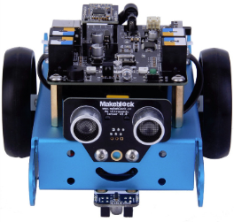**Goal:**

In this lab you will be learning how to make Mbot move forward, backwards and stop using different speeds.

**mBlock Software:**

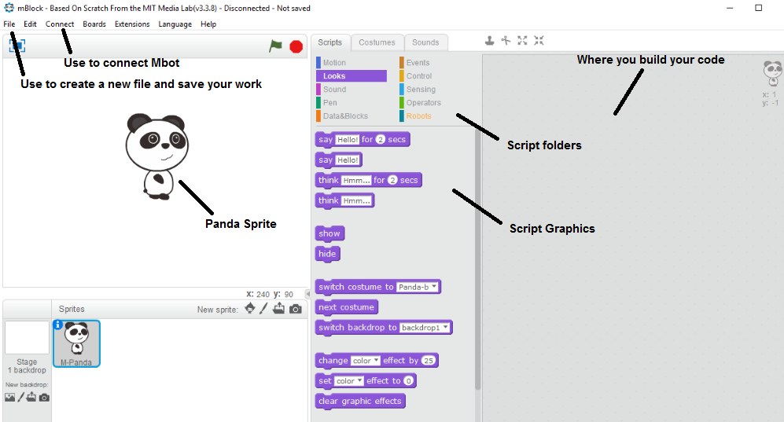Open the mBlock program on your computer, a window will open showing you the following screen.

Some parts of this screen will look similar to other programs like the file drop down tab. This tab will allow you to save your work and create new files. The connect drop down tab will let you connect to Mbot. In the upper center you will see a number of different script folders like Robots, Motion, Event and more. When you click on a folder you will see the connected script graphics. On the right you will find a large space where you can drag and drop graphics to build your code.

Find the following script graphics and drop them in the section on the right.

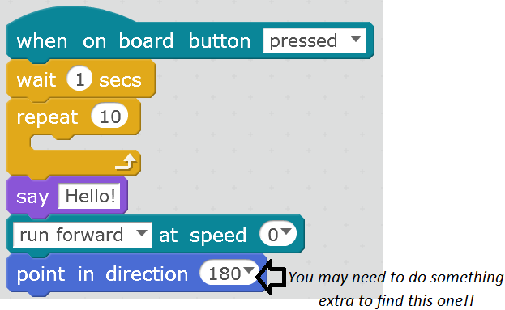

*🡨 You may need to do something extra to find this one!!*

Have the teacher check this off before moving forward

**Moving Mbot:**

Click and drag your script graphics back to where you found then. You will notice that they have now been removed.

Under the Scrip file “Robots” find:

and place it in the right screen.

Once the program is loaded on Mbot, this will allow you to press the reset button on top to start your program over and over.

Now place:

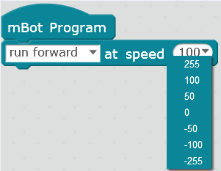 just below your last entry allowing them to lock together.

Set the speed to 100. This will allow both motors to run forward. If you select 255 Mbot will run faster and if you select a negative number Mbot will run backwards.

If Mbot was to run this program right now it would just drive forward forever until it ran out of power or hit something. We want to give it an amount of time that it can travel for.

Select:

and lock it at the bottom of your last command. Set the time to 3 secs.

Now Mbot will drive forward for 3 seconds and wait for its next command.

Make your screen look like the following:

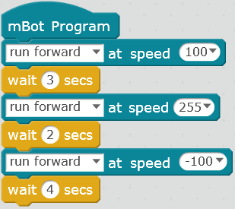Explain below what Mbot will do in six steps if it ran this program?



We want to end Mbot’s program we could tell it to but it would be better to shut of the motors completely. Add the following script twice:

And set one to M2 which means motor 2.

Now both motors will be at a complete stop. Your program should look like the image below:

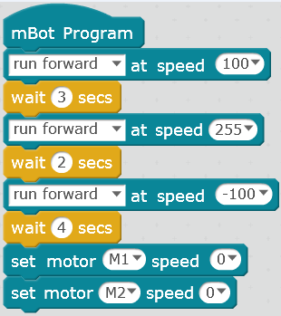

Have the teacher check this off before moving forward

*🡨 You may need to do something extra to find this one!!*

**Connecting Mbot to the Computer:**

Before plugging Mbot into the computer, make sure the On/Off switch is in the off position. Someone’s previous program may be loaded on Mbot and it could start driving if it is not off. Stand the Mbot on its back away from the edge of the counter. Plug in the provided USB to the computer and Mbot and turn it on.

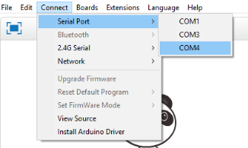Click on Connect in the top left corner of the screen and select Serial Port and COM4. If COM4 is not there try a different one.

The top of your screen should read Serial Port Connected like the image below:



Go to Edit and Arduino Mode:

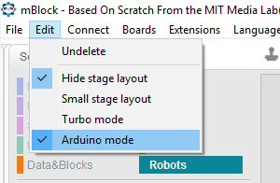

On the right a new window will open. At the top left of that window you will see a button called “Upload to Arduino” click on it.

Once the upload is complete unplug the USB cable, find a safe clear place to run the Mbot. Press the green button and stand back.

*🡨 You may need to do something extra to find this one!!*

Have the teacher check this off before moving forward

* Turn off the board and unplug the battery!

**Questions:**

Did your Mbot drive straight or did it turn a little while moving?

___________________________________________________________________

What would happen if you didn’t add the “Wait” command?

___________________________________________________________________

What are two ways to stop the motors?

___________________________________________________________________

What do you think would happen if you tell Mbot to move forward at a negative speed?

___________________________________________________________________

Did you turn off your Mbot and unplug that battery pack?

___________________________________________________________________

What steps do you take in mBlock to connect Mbot?

___________________________________________________________________

What steps do you take in mBlock to upload to Mbot?

___________________________________________________________________

What do you think would happen with Mbot’s motors if you tell it to move right instead of forward?

__________________________________________________________________