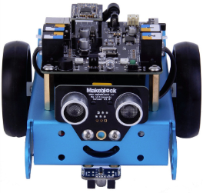
Goal:
In this lab you will be learning how to make Mbot move straight forward, straight backwards and turn.
mBlock Software:
Open the mBlock program on your computer for this lab.
Moving Mbot Straight:
In the last lab we told Mbot to move forward and backwards. Mbot moved but it may not have moved straight. This is due to not all motors being of equal build quality. We are now going to recreate the end result from the last lab using better code.
Under the Scrip file “Robots” find:
and place it in the right screen.
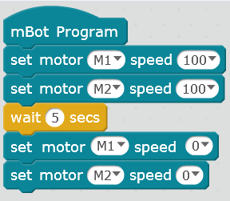
Now place the following commands in:
Upload this to your robot and see if it travels straight for 5 second.

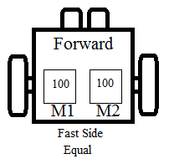
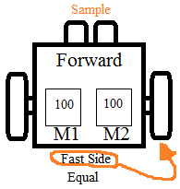

If your Mbot turns one way, that means one motor is rotating faster than the other. Record what motor is running faster on the side image.
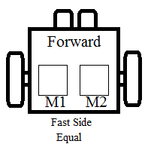
Increase the speed on the slower wheel and upload the program again. Is the robot driving straight? Is it better or worse? Record your changed.
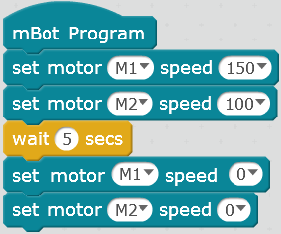

Keep repeating this process until the Mbot is traveling in a straight line. Record your final amount since you will need this in the future.
You may need to do something extra to find this one!!

Have your teacher watch your Mbot travel in a straight line and have him sign off before you move forward
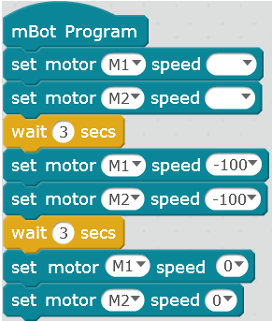
The numbers may be different going backwards compared to forwards. Add the following commands into your program without changing your forward setting that you found:
Upload these settings and see what the Mbot does. Record your findings and adjust your amounts until the Mbot can travel both forwards and backwards in a straight line.

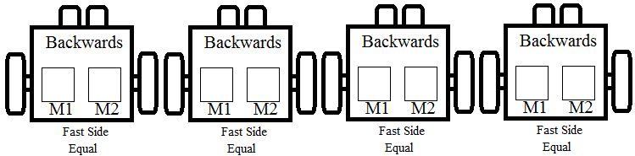
Have your teacher watch your Mbot travel in a straight line and have him sign off before you move forward
You may need to do something extra to find this one!!

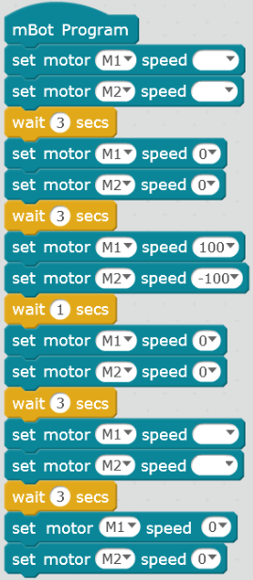
Turning Mbot:
We are going to use the same commands to turn Mbot. This time we will be using one positive value and one negative value. This will allow one wheel to travel forwards while the other travels backwards. When both wheels turn in opposite directions Mbot will turn on the spot.
Enter the following commands and enter your forward speeds in the blank bubbles.

The speed settings of 100 and -100 may not give you a nice 90 degree turn. Adjust these numbers until your Mbot drives straight, turns 90 degrees and drives straight.

Have the teacher check this off before moving forward
You may need to do something extra to find this one!!

- Turn off the board and unplug the battery!
Questions:
You entered a positive and negative number for your motors to turn one direction. How would you turn the other way?
___________________________________________________________________
Why do you have to enter different numbers to have your Mbot go straight?
___________________________________________________________________
What would you have to do to may a turn at a 45 degree angle?
___________________________________________________________________
How could you make your Mbot drive a longer or shorter distance?
___________________________________________________________________
Did you turn off your Mbot and unplug that battery pack?
___________________________________________________________________

