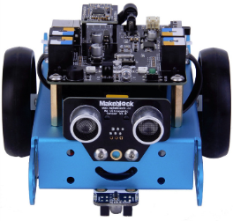**Goal:**

In this lab you will be learning how to make Mbot moving forward, backwards and turn easier.

**mBlock Software:**

Open the mBlock program on your computer for this lab.

**Making Custom Blocks:**

In the last lab we figures out how to make Mbot go straight by adjusting values. This took a lot of time and that time was worth it since we can now make a custom block so we never have to do that again.

Click on the Data and Blocks Scripts folder and click on

Enter Drive Forward into the tab and press OK

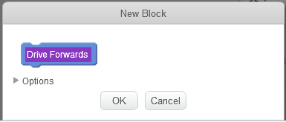

A define “Drive Forward” block will appear on your screen. Add your drive forward commands and numbers to it and place it off to the side of the screen.

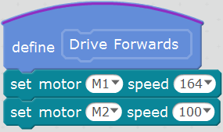

Do this again naming one “Motors All Stop” and another called “Turn Right 90 Degrees” using your other values.

You can now build the same code as lab 3, but this time use the new blocks found in the “Data&Blocks” folder.

***Note***

If you delete your new define code you will lose the new blocks

Make your screen look like the below picture but with your own numbers and show your teacher so he may sign off on it before moving forwards

*🡨 You may need to do something extra to find this one!!*

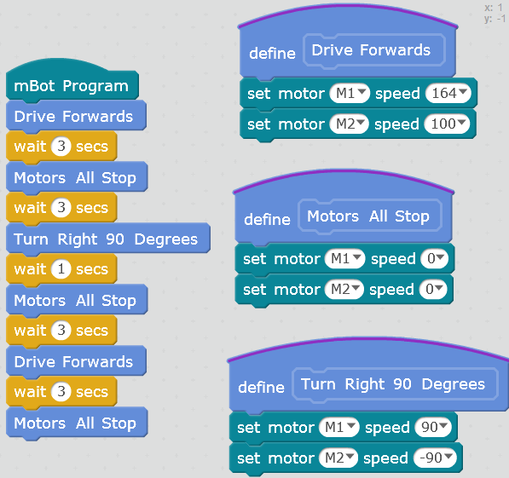

*🡨 You may need to do something extra to find this one!!*

Upload your code and show your teacher your Mbot in action

* Turn off the board and unplug the battery!