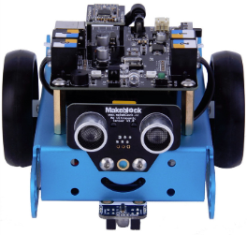**Goal:**

Mbot is lost and you need to get it home. You will need to program Mbot to navigate a maze laid out inside of a robot arena. It must avoid all markings that are at a right angle. To get an exceeding it must also avoid the center marking at a 45 degree angle.

Good Luck

**Maze Image:**

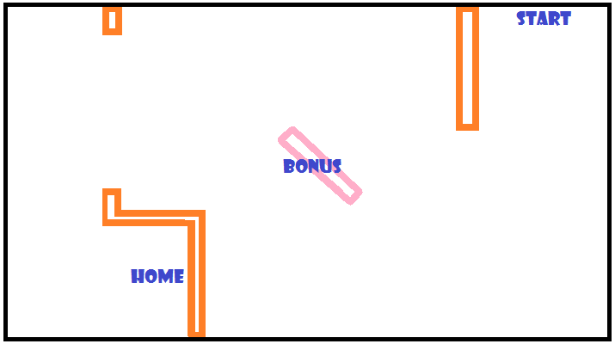

*🡨 You may need to do something extra to find this one!!*

Upload your code and show your teacher your Mbot in action

* Turn off the board and unplug the battery!